

**Week 2**

Servlet: Data Sharing and Database Management

Web Programming 2

|  |  |
| --- | --- |
| NAME | MARLIANTI BT MUFPIARLIS |
| NO. MATRIKS | S66353 |

Lecturers

PUSAT PENGAJIAN INFORMATIK DAN MATEMATIK GUNAAN (PPIMG), UNIVERSITI MALAYSIA TERENGGANU (UMT)

# Revision History

|  |  |  |  |
| --- | --- | --- | --- |
| **Revision Date** | **Previous Revision Date** | **Summary of Changes** | **Changes Marked** |
|  |  | First Issue | Mohamad Nor Hassan |
|  |  | Second Issue | Dr Rabiei Mamat Dr Faizah Aplop Dr Fouad  Ts Dr Rosmayati Mohemad  Fakhrul Adli Mohd Zaki |
| 13/03/2019 | 21/02/2019 | Addition of Revision History, Table of Contents, Formatting  Cover Page | Fakhrul Adli Mohd Zaki |
| 15/03/2019 |  | Add Task1, Task 2, Task 3 and  Task 4 | Fakhrul Adli Mohd Zaki |

Table of Contents

Task 1: Data Sharing in Servlet 5

Task 2: Creating A Table in MySQL Database 15

Task 3: Setting the Environment of Web Application for Database Connection

........................................................................................... 20

Task 4: Using Servlets for Database CRUD Operations 23

# Arahan:

Manual makmal ini adalah untuk kegunaan pelajar-pelajar Pusat Pengajian Informatik dan Matematik Gunaan (PPIMG), Universiti Malaysia Terengganu (UMT) sahaja. Tidak dibenarkan mencetak dan mengedar manual ini tanpa kebenaran rasmi daripada penulis.

Sila ikuti langkah demi langkah sebagaimana yang dinyatakan di dalam manual. Tandakan (√) setiap langkah yang telah selesai dibuat dan tulis kesimpulan bagi setiap aktiviti yang telah selesai dijalankan.

***Instruction:***

*This laboratory manual is for use by the students of the School of Informatics and Applied Mathematics (PPIMG), Universiti Malaysia Terengganu (UMT) only. It is not permissible to print and distribute this manual without the official authorisation of the author.*

*Please follow step by step as described in the manual. Tick (√) each step*

*completed and write the conclusions for each completed activity.*

**Task 1: Data Sharing in Servlet**

|  |  |
| --- | --- |
| **Objective:** | To use servlet for request forwarding and data sharing |
| **Problem Description:** | Write a login form and a servlet to authenticate a user. |
| **Estimated time:** | 30 minutes |

1. Create a directory F:\CSF3107-SXXXXX (only if you have not created it yet). Note: Replace *XXXXX* with your matric number.
2. Go to F:\CSF3107-SXXXXX\ directory and create sub-directory and name it as *Lab 2*.
3. Open your NetBeans IDE.
4. Go to File -> New Project

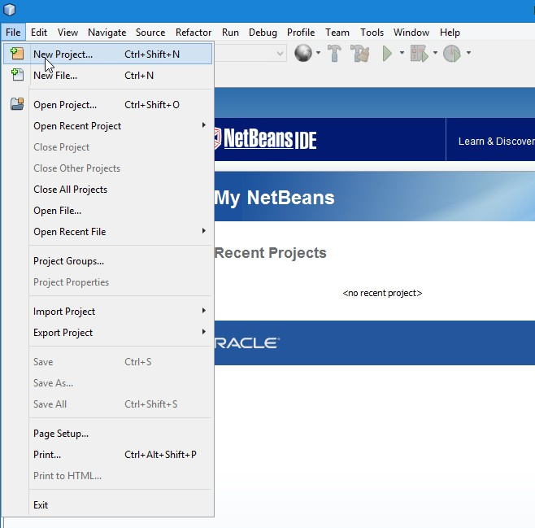

1. Select Java Web -> Web Application and click Next.

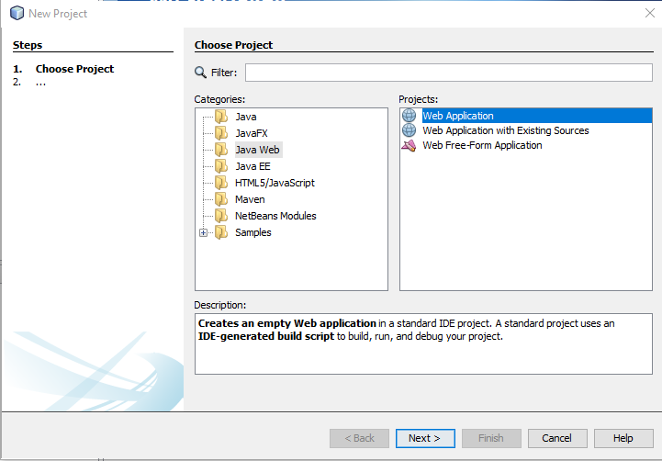

1. Type Project Name: *ServletDataSharing*.
2. Click Browse and choose Project Location: F:\CSF3107-SXXXXX\Lab2. Then click the Next button.

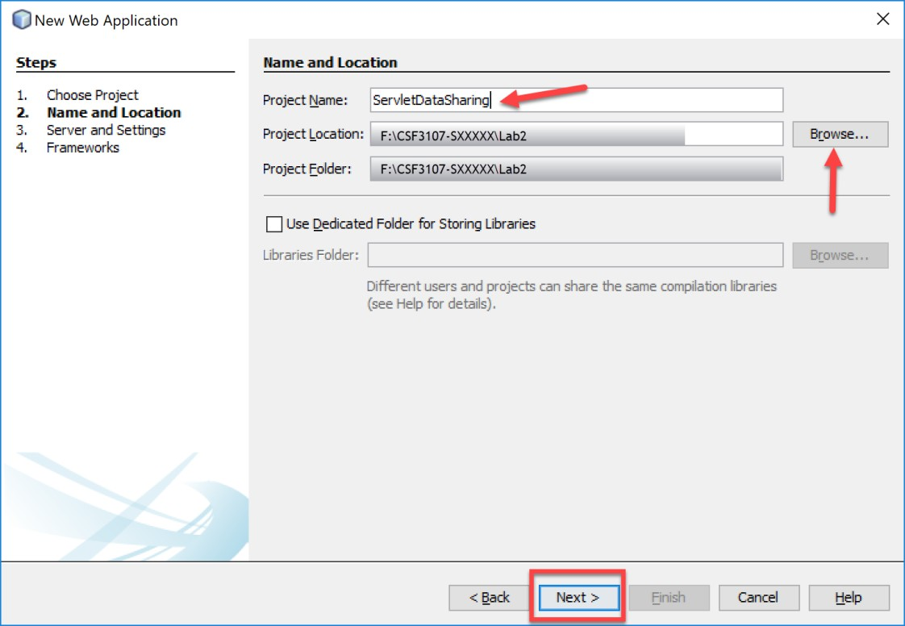

1. Then, choose Apache Tomcat as the server and click Finish.

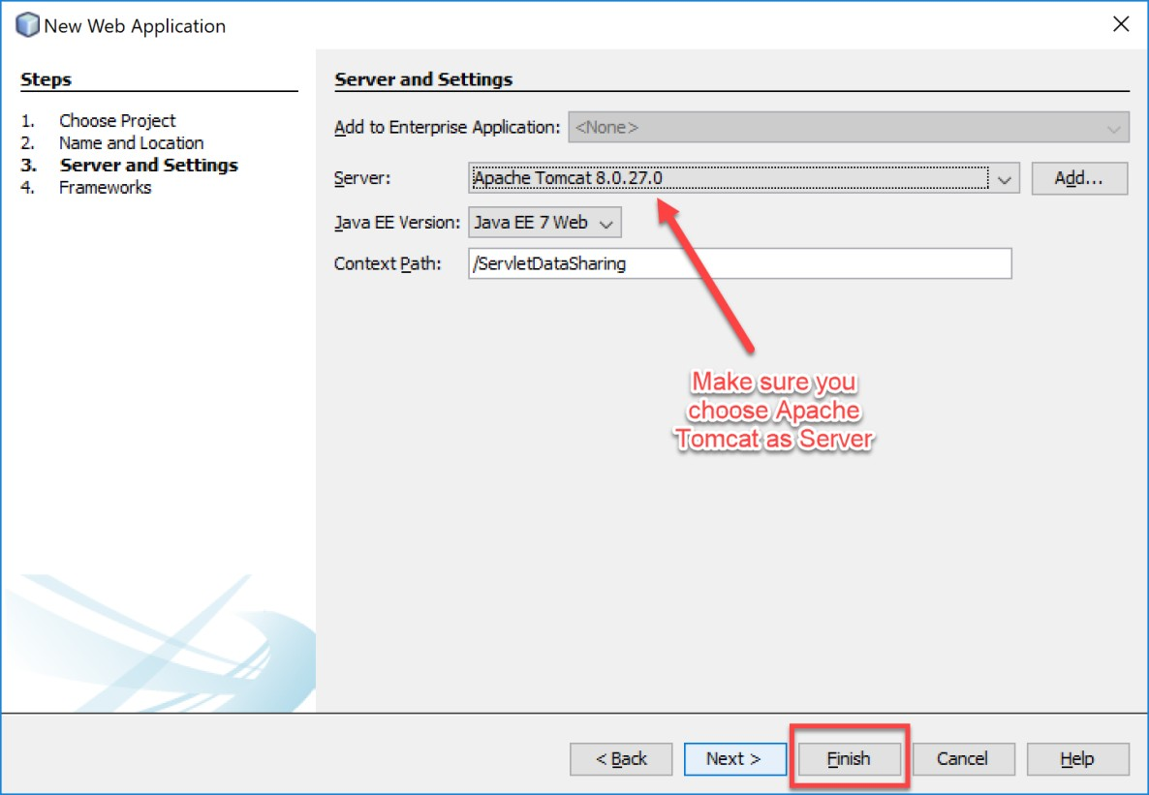

1. You will see your project structure on the left side of your Netbeans editor. Next, you will create an HTML file for a login page. Follow the instructions as shown on the following screenshot.

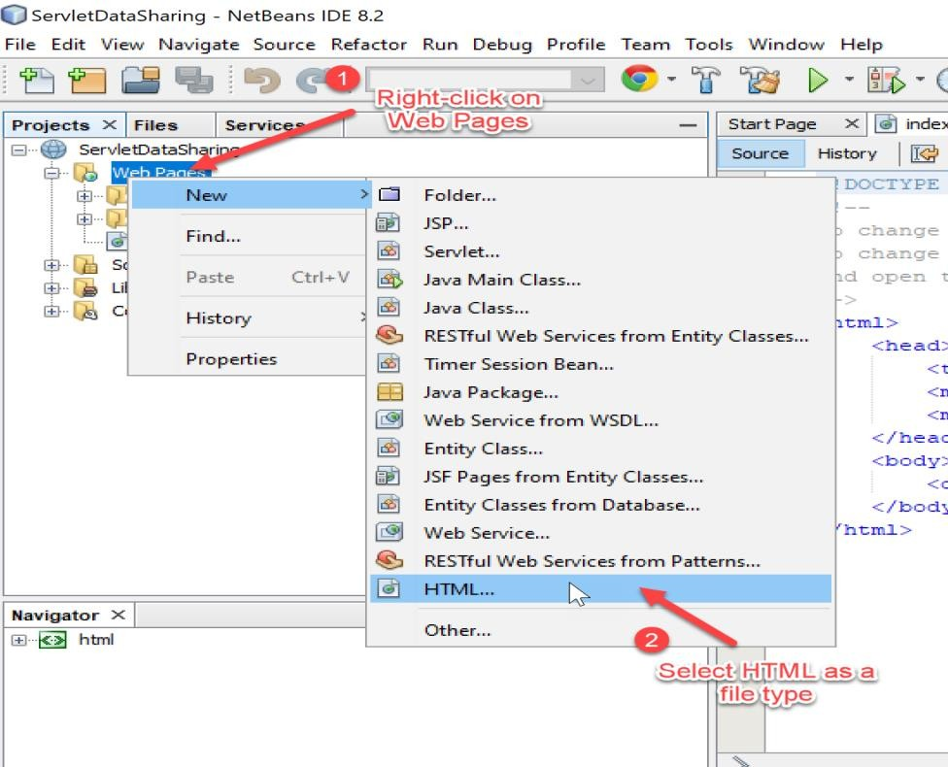

1. Name your HTML file as ‘login’, then click Finish.

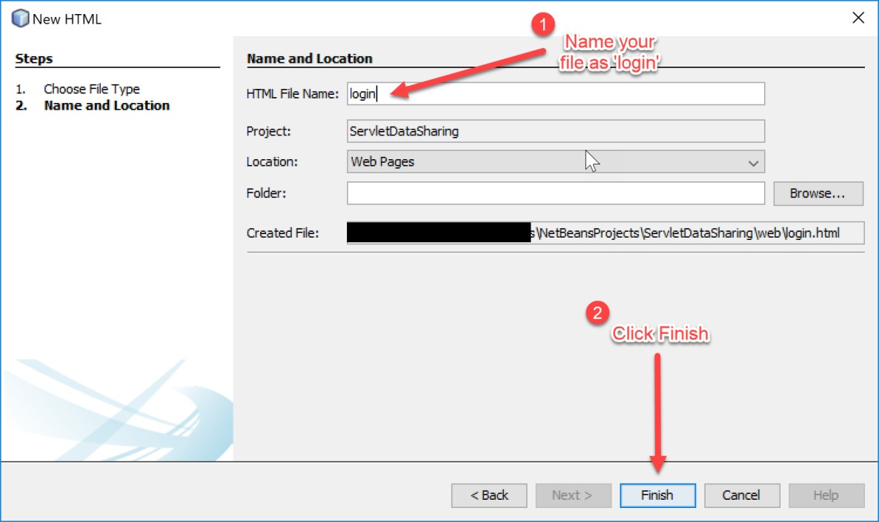

1. Type the following HTML markups into your login.html.

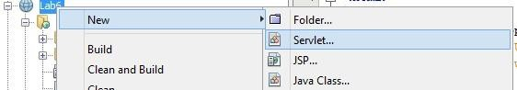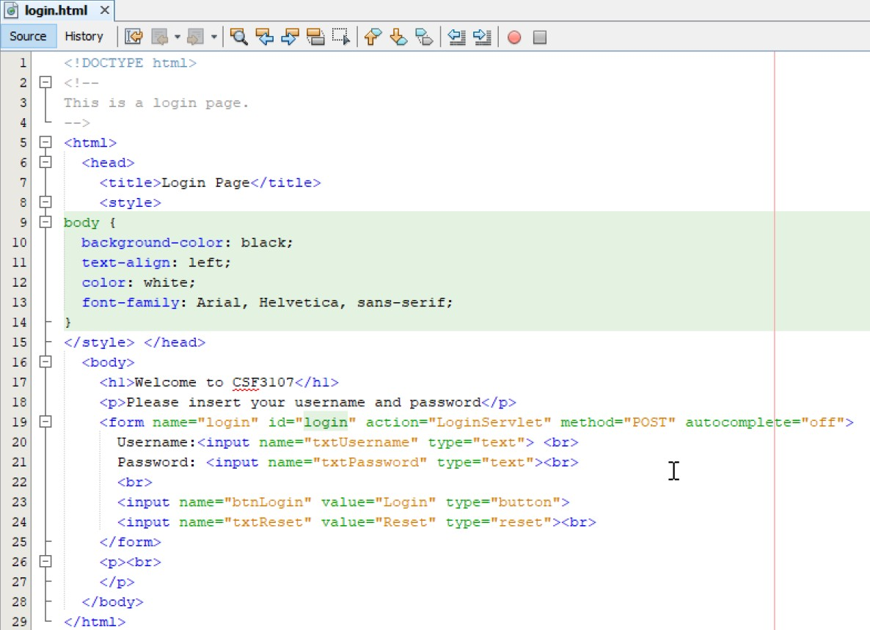

1. Next, we are going to create a servlet to process the username and password insert by the user on the login form. We start it by creating a new file for our servlet. Follow the steps below:

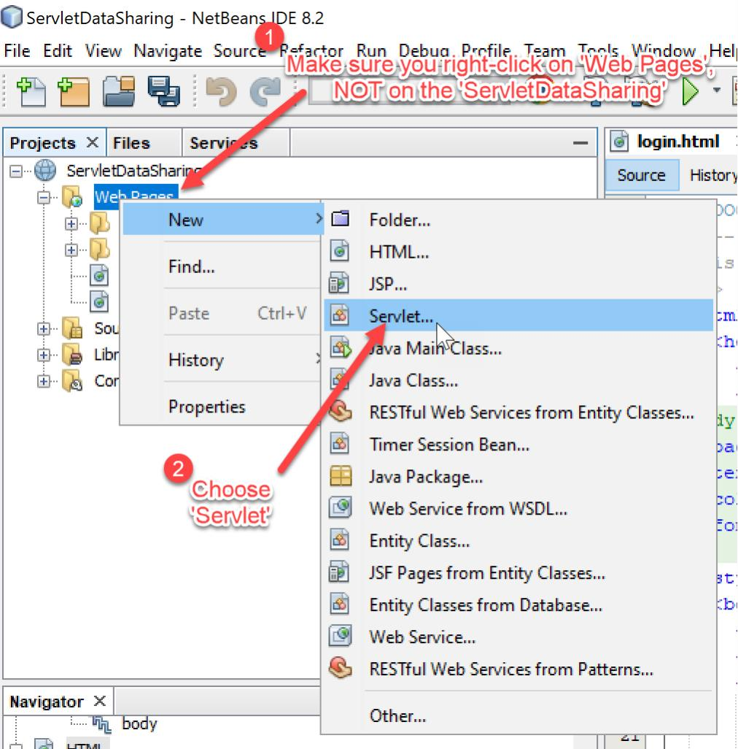

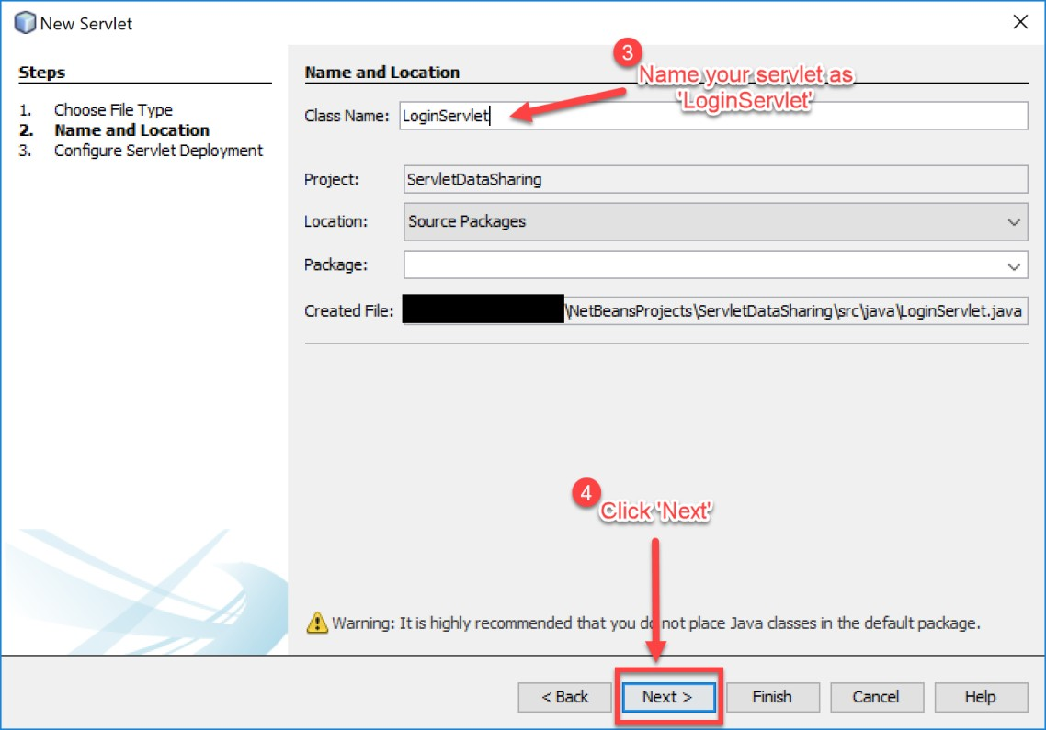

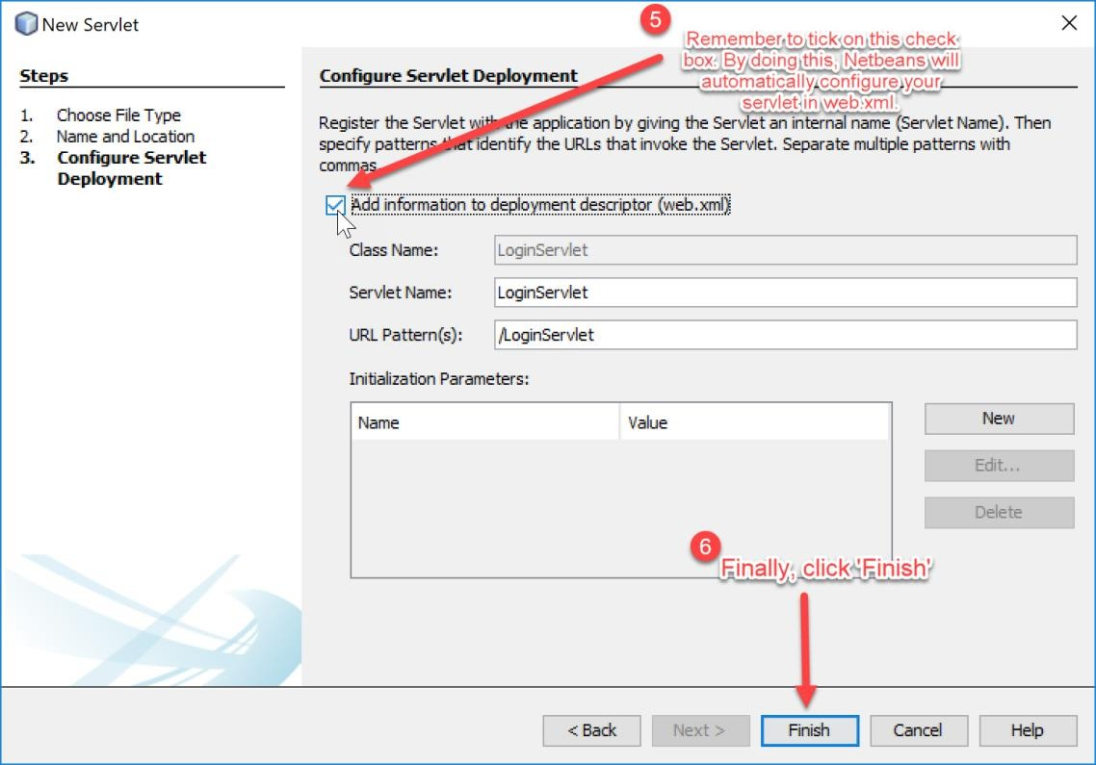

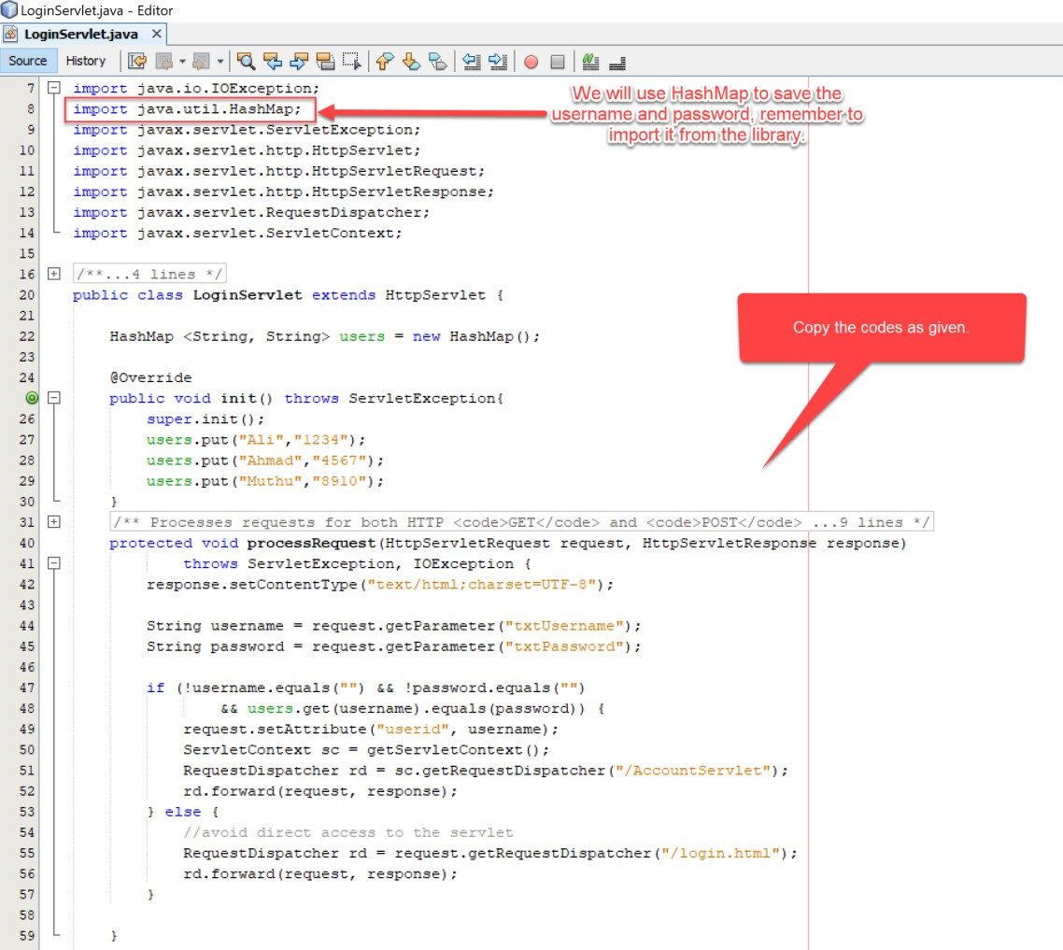

1. Next, we need a servlet to return the information about users’ accounts and display it on the browser. Repeat previous step for creating a new servlet and fill the details as shown on the screenshots below.

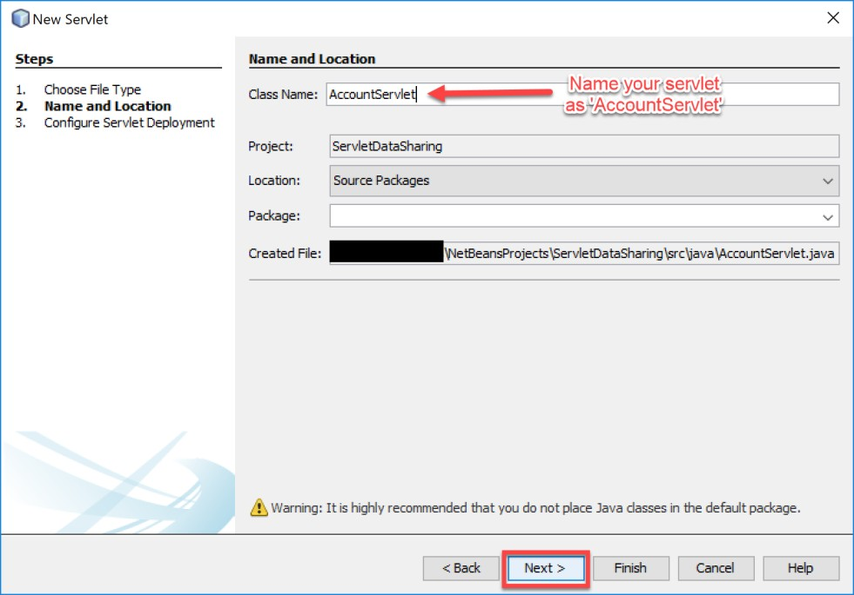

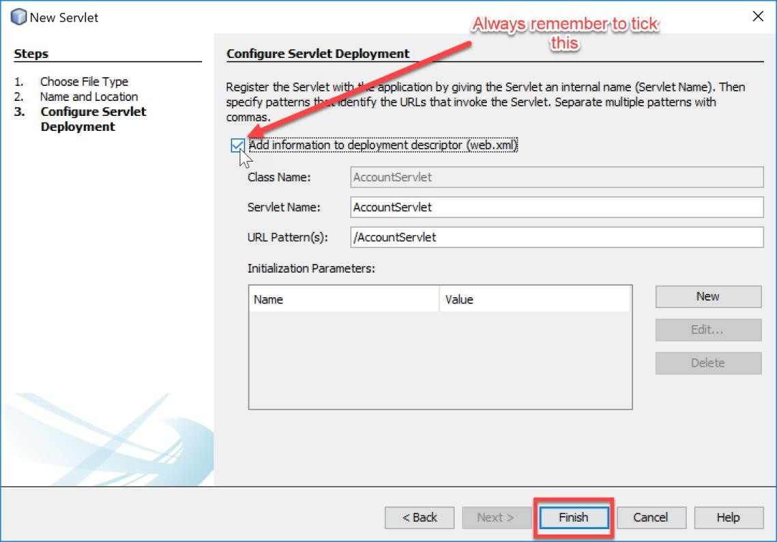

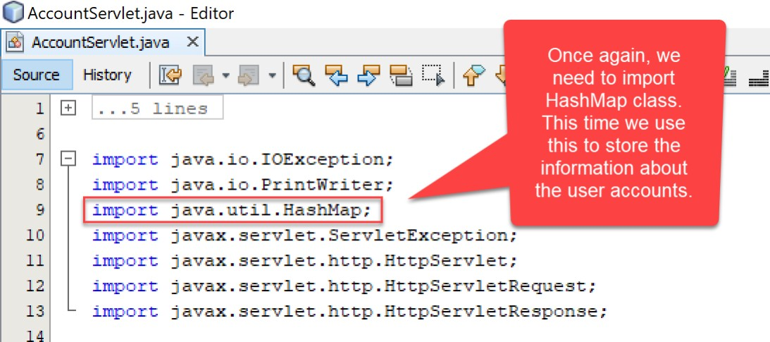

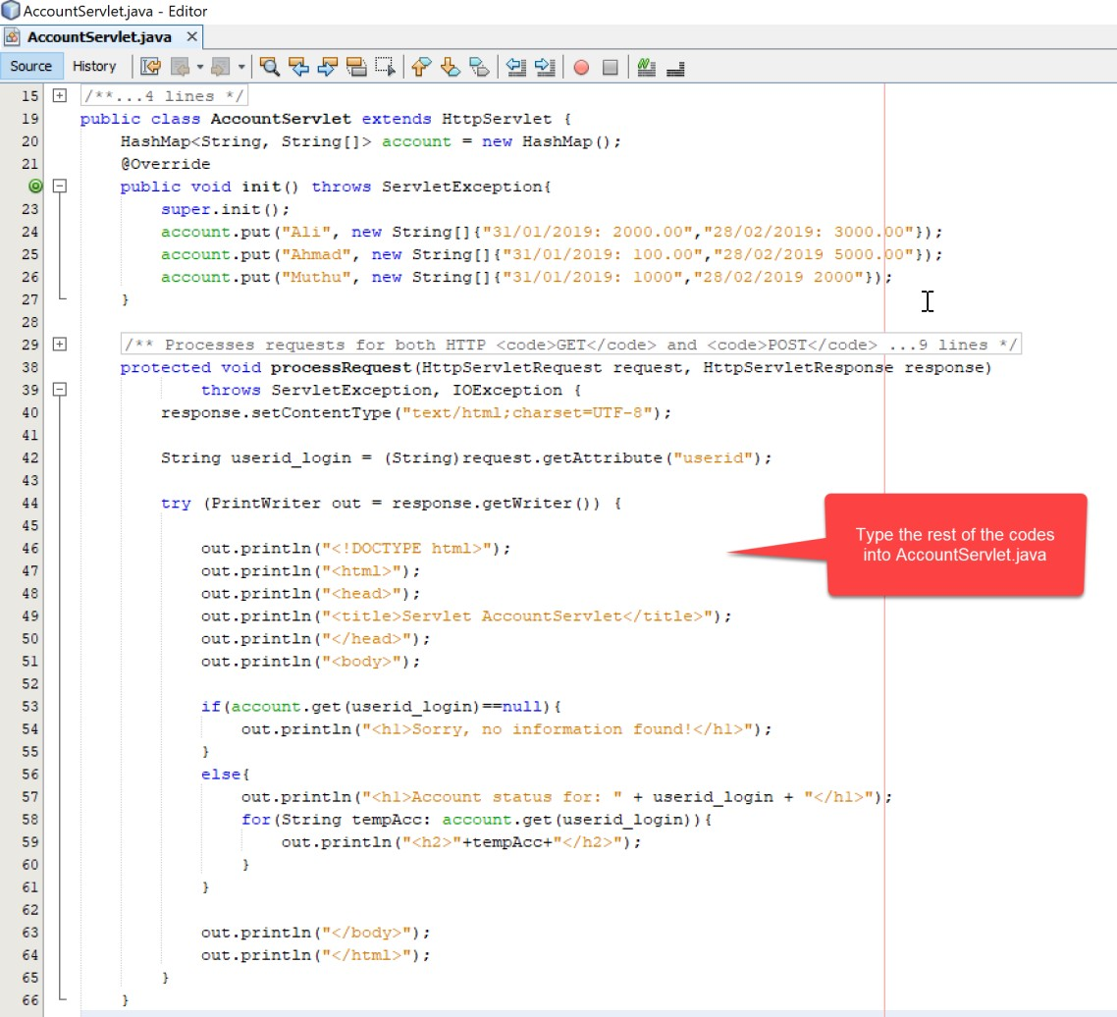

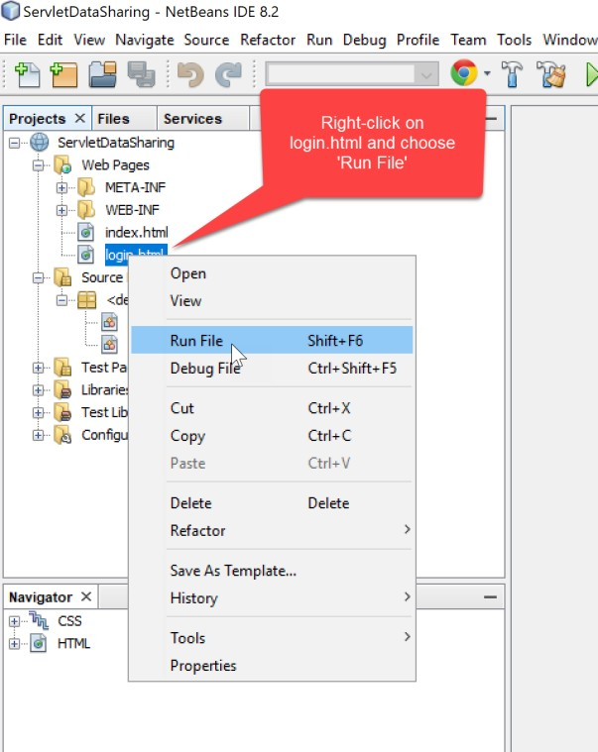

1. The Output will appear in a web browser. Put a Username as ‘Ahmad’ and Password as ‘4567’, then click *Login*.

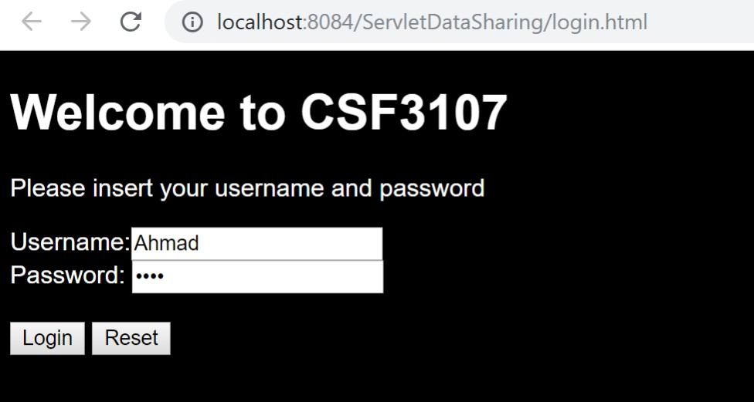

1. If you have followed all the previous steps correctly, you will see the account information of a user named ‘Ahmad’. Repeat step 14 with other users as input and see the result.

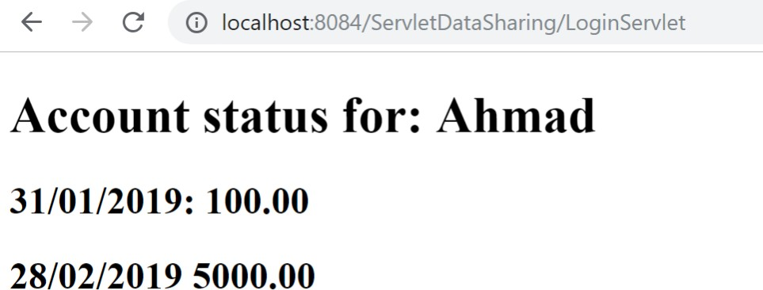

# Reflections:

* 1. What have you you learnt from this exercise?

I’ve learned created a servlet to process the data

* 1. What are the common methods used in Java Servlet?

**doGet(HttpServletRequest request, HttpServletResponse response)**

**doPost(HttpServletRequest request, HttpServletResponse response):**

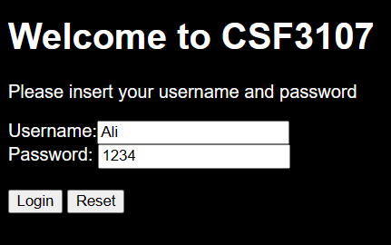

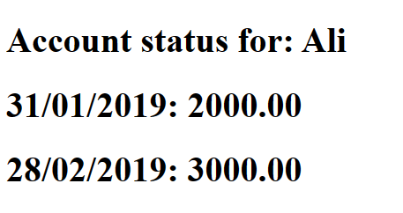

**Task 2: Creating A Table in MySQL Database**

|  |  |
| --- | --- |
| **Objective:** | To create a MySQL table to store user credentials |
| **Problem Description:** | Prepare a user table to be used in Web Application |
| **Estimated time:** | 30 minutes |

* + 1. 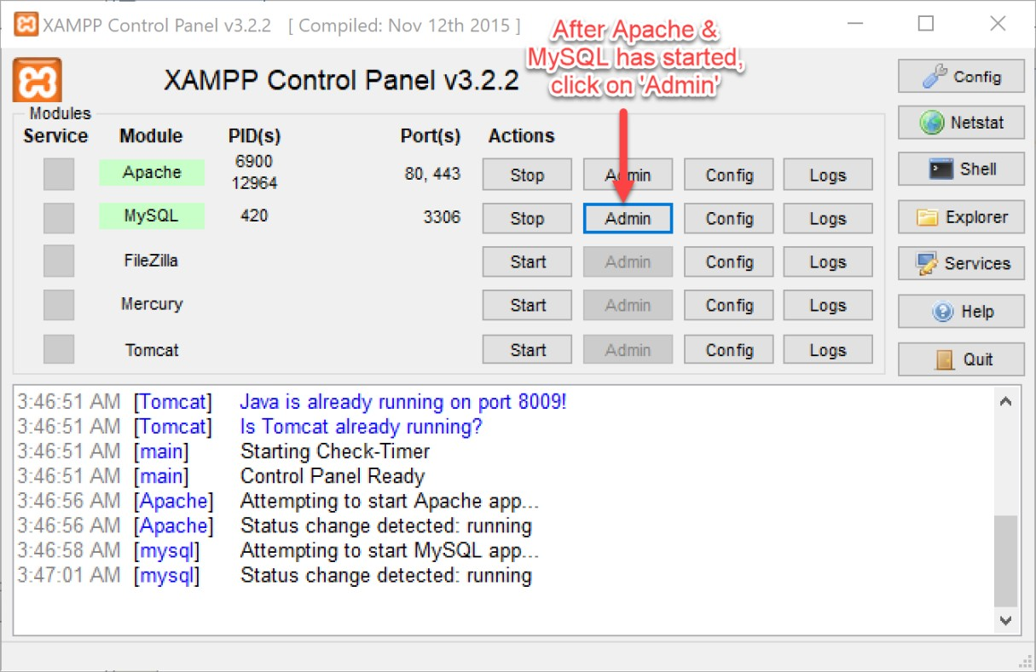Start Apache and MySQL.
    2. 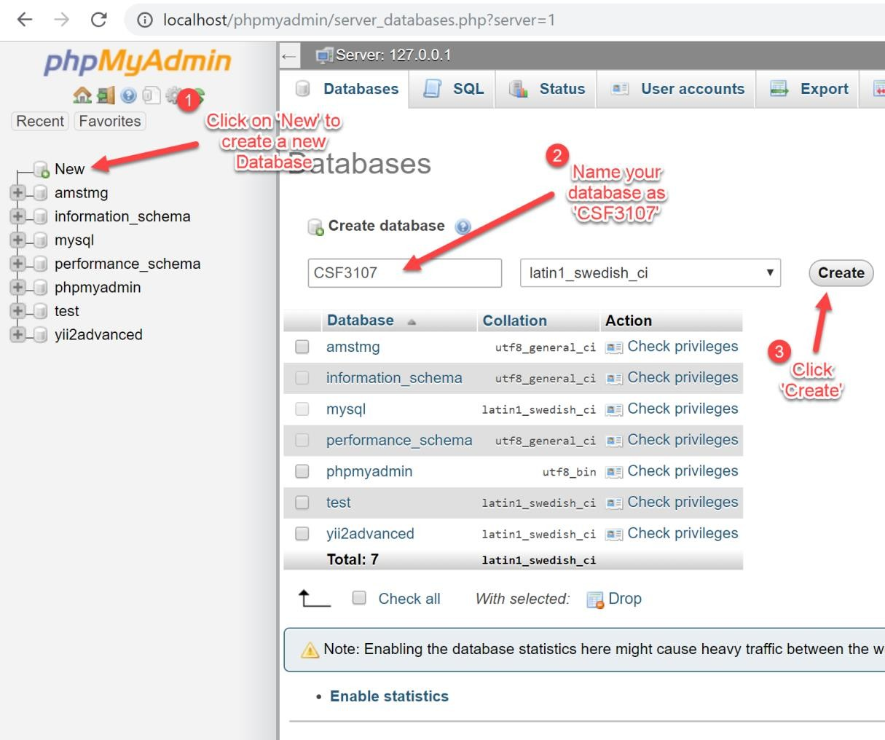Create a new database.
    3. After the database has been created, now we are going the create a table

named ‘users’. This table has four columns.

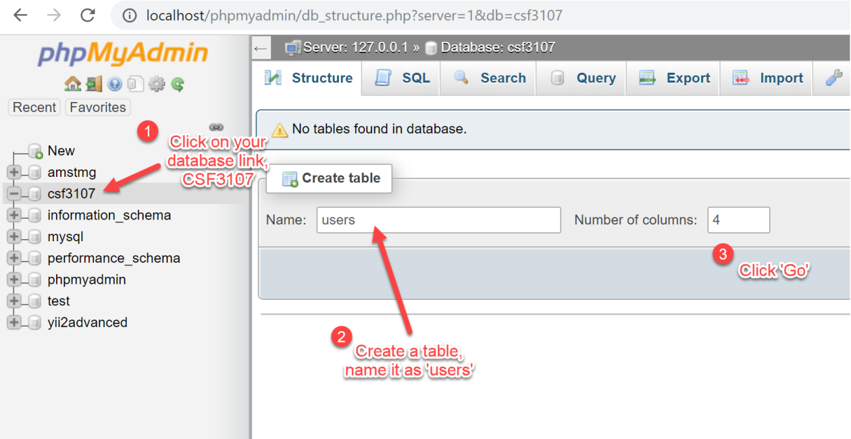

* + 1. Setup the table ‘users’ as below:

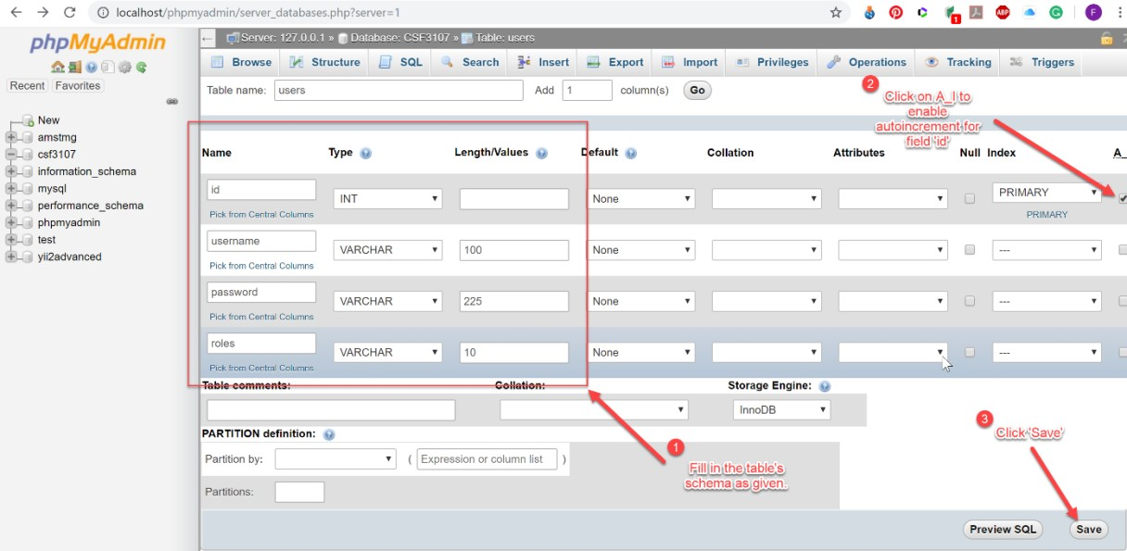

* + 1. After you tick for auto-increment, this dialogue box will appear, leave the

settings as it is and click ‘Go’.

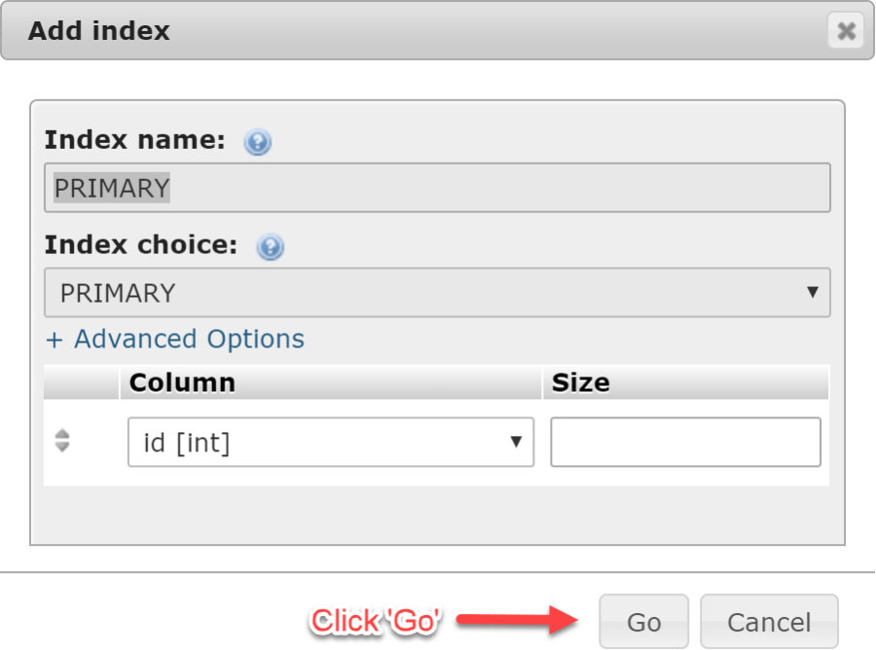

* + 1. Your newly created table can be seen on the left phpMyAdmin.

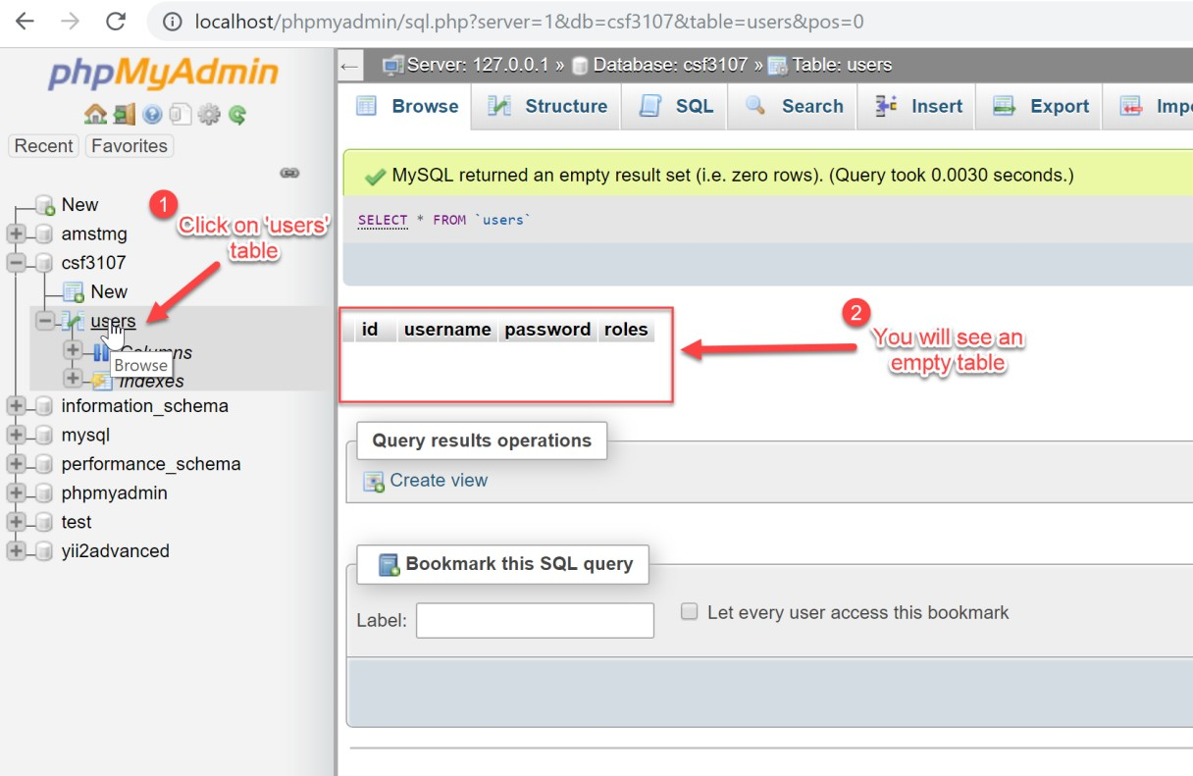

* + 1. 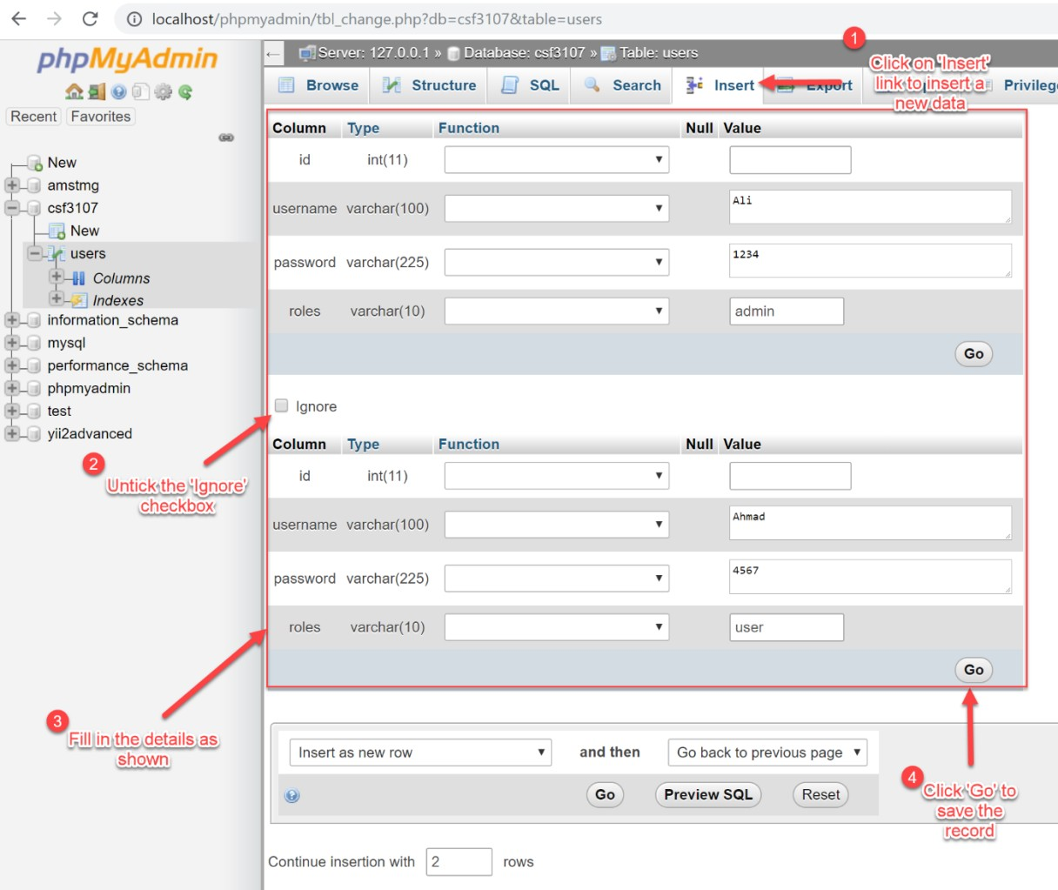You may insert some data into the table by following the steps on the screenshot.

18

* + 1. After you have clicked the ‘Go’ button in the previous step, you will see an autogenerated SQL query on the phpMyAdmin page. To view the data, click Browse.

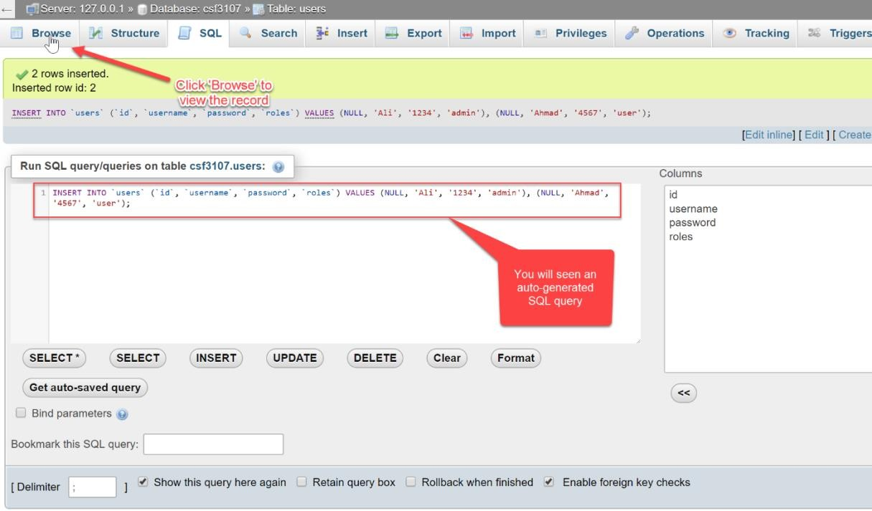

* + 1. You will see the data of the users. Now, we have finished this task.

**Note:** In a real implementation, you should encrypt the password and never display the original form of it.

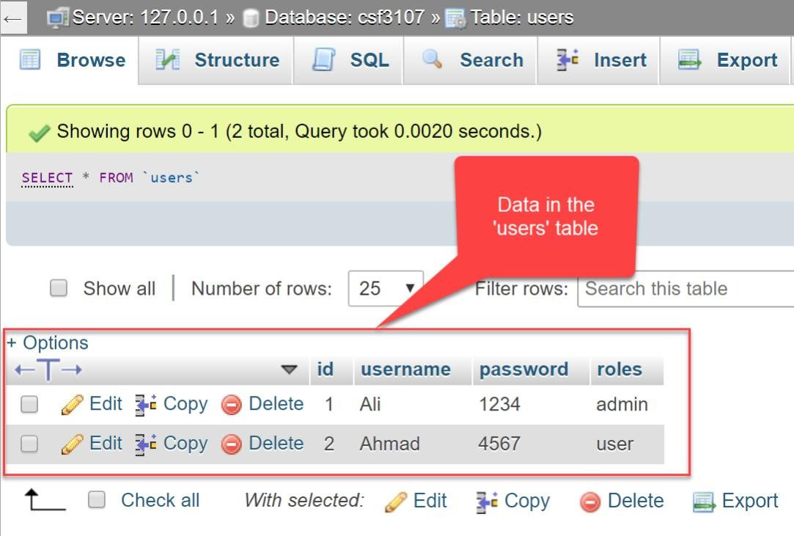

**Task 3: Setting the Environment of Web Application for Database Connection**

|  |  |
| --- | --- |
| **Objective:** | To set up a proper environment for integrating web application to the database |
| **Problem Description:** | Import MySQL JDBC Library to an existing project |
| **Estimated time:** | 5 minutes |

1. Create a new Web Application Project.

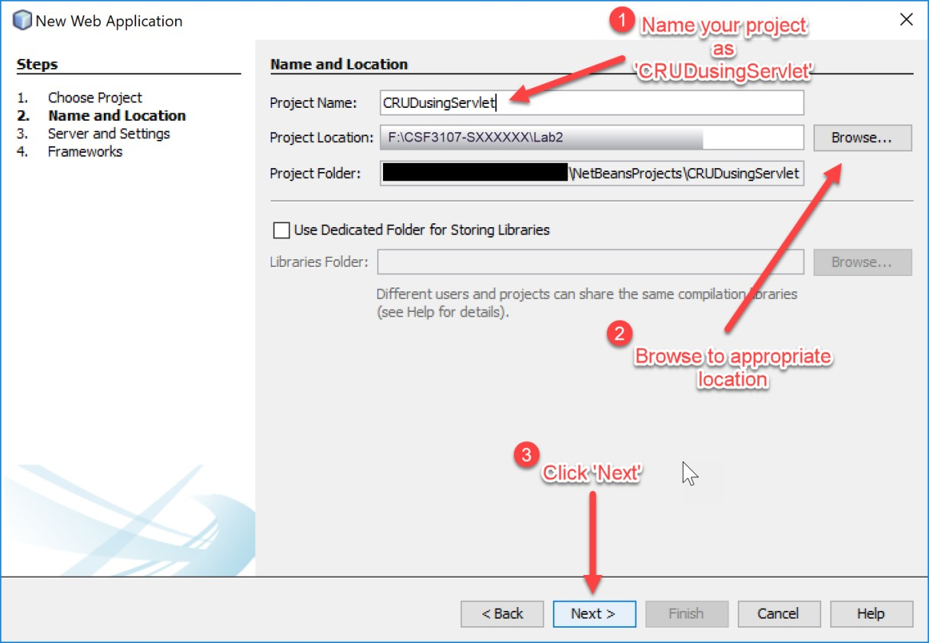

1. Use Apache Tomcat as our application server.

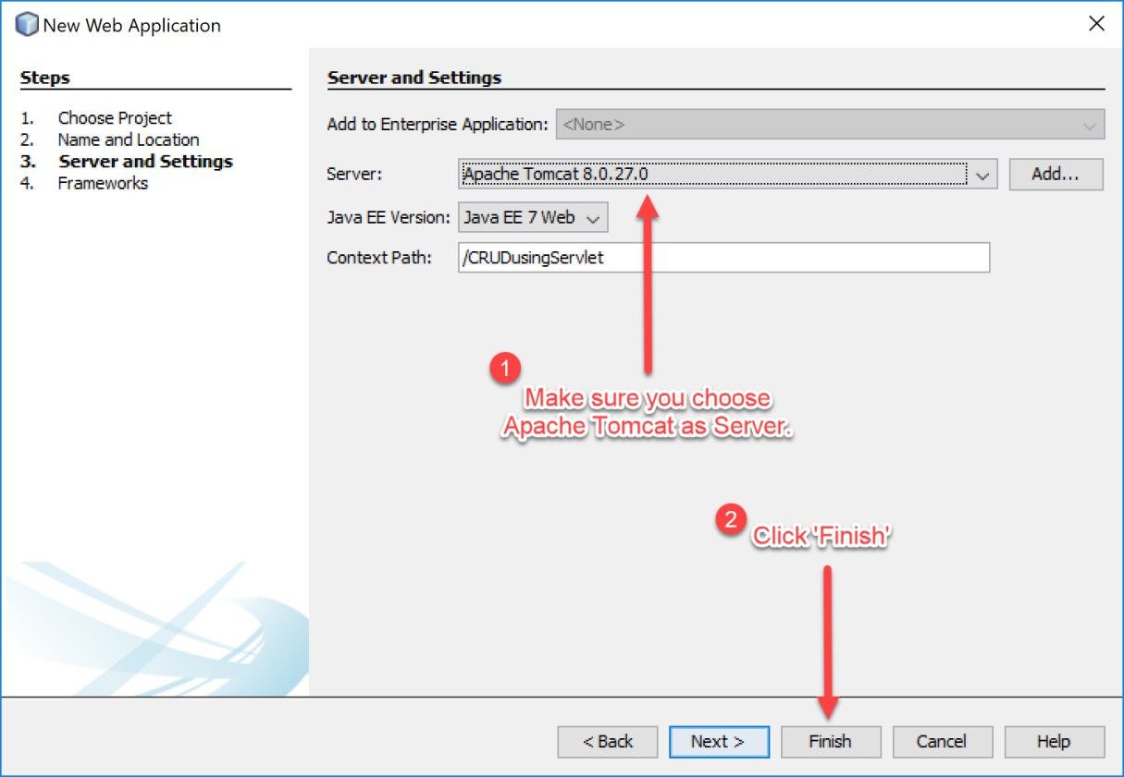

1. Once finished, right-click on Project’s name *(CRUDusingServlet)* and choose

*Properties.*

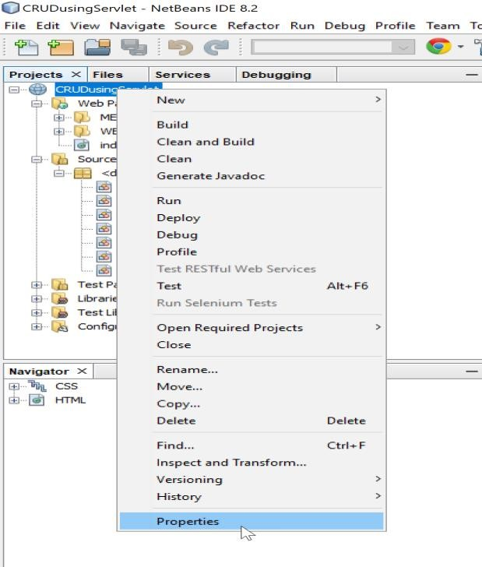

1. Next, import the MySQL JDBC Driver library.

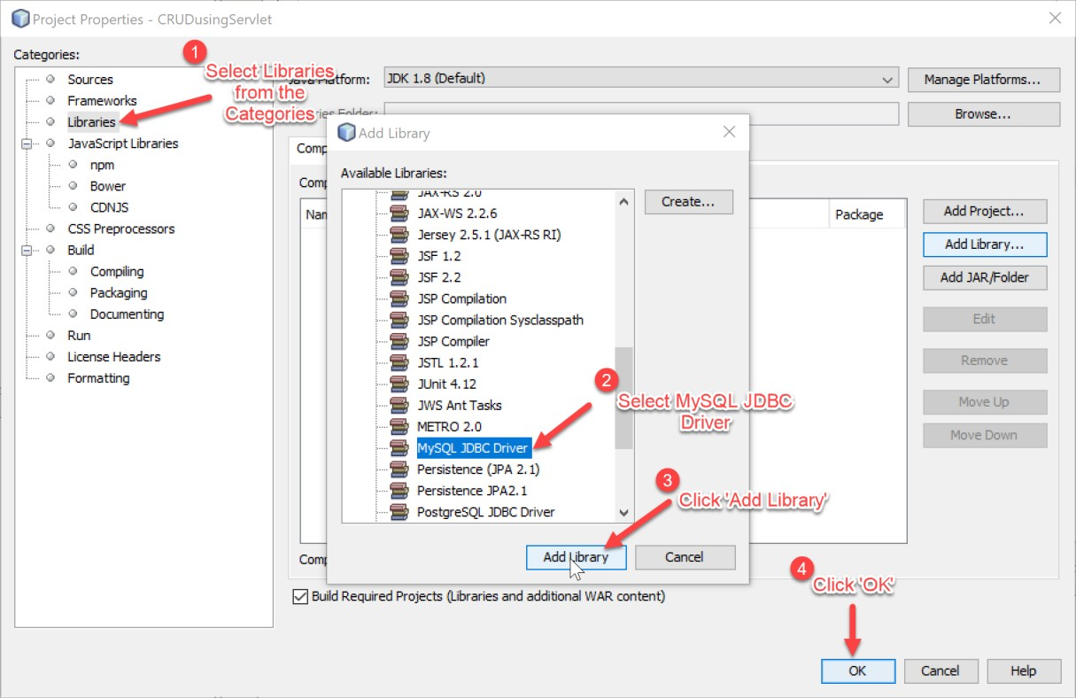

1. Now your application is ready to connect to MySQL database and execute a SQL query.

**Task 4: Using Servlets for Database CRUD Operations**

|  |  |
| --- | --- |
| **Objective:** | To program multiple servlets for manipulating the database |
| **Problem Description:** | Program five different servlets to handle database operations such as insert, update and delete.   1. SaveServlet.java: to save data into the database 2. ViewServlet.java: to view data retrieved from database 3. EditServlet.java & EditServlet2.java: to edit existing data 4. DeleteServlet.java: to delete existing data   Apart from the servlets, we are going to develop two custom Java class know as JavaBeans and Data Access Object (DAO). |
| **Estimated time:** | 90 minutes |

1. Open the Web Application Project *(CRUDusingServlet)* created in Task 3.
2. 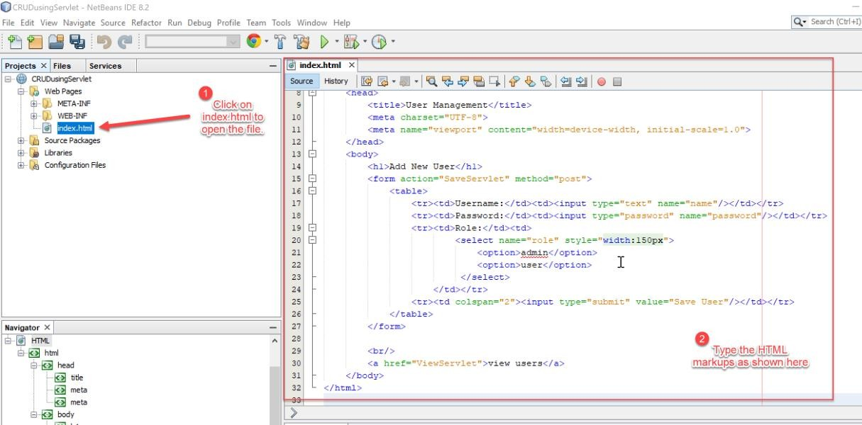Open the index.html file and edit as follows.
3. Now we are going to create a Java class which is specially used to store the user data.

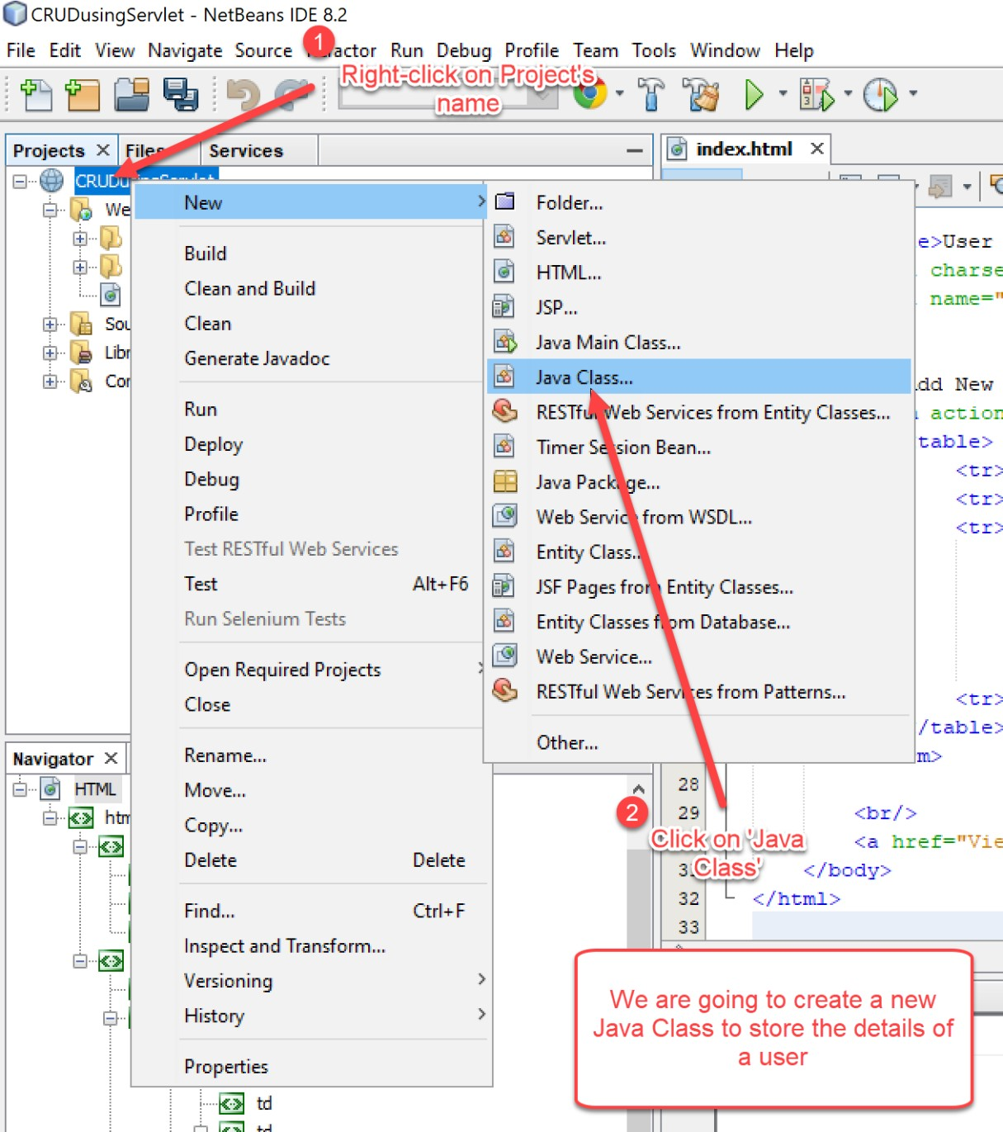

1. Name the Java class as *User*.

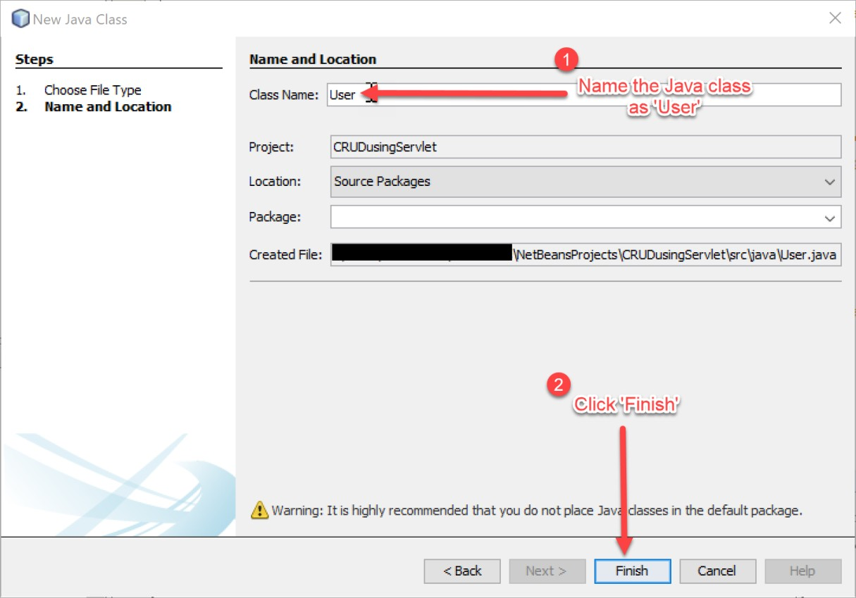

1. Type the following codes in User.java file.

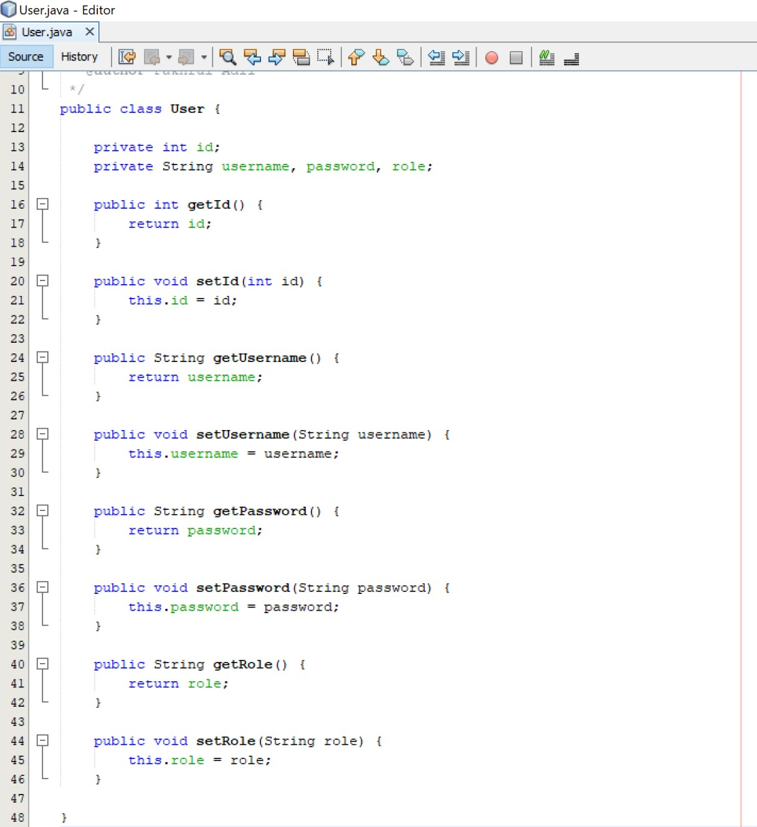

1. Next, we need to program the Data Access Object (DAO) class which is used for managing database connection and SQL operations.

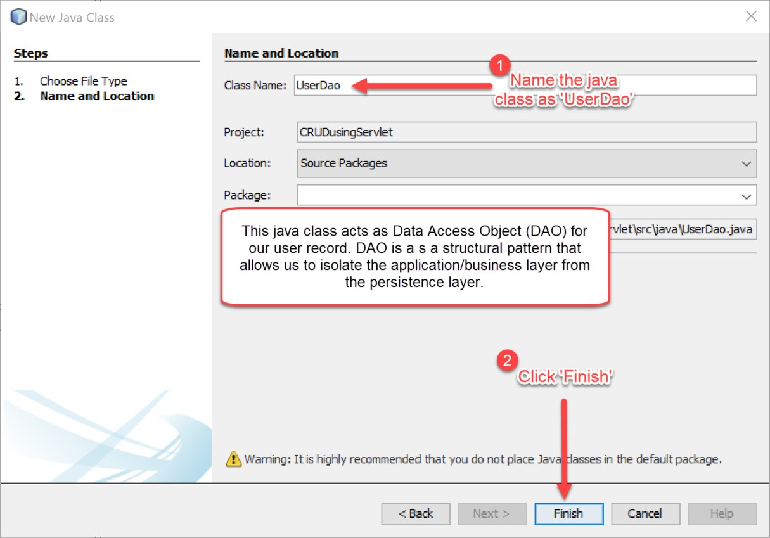

1. 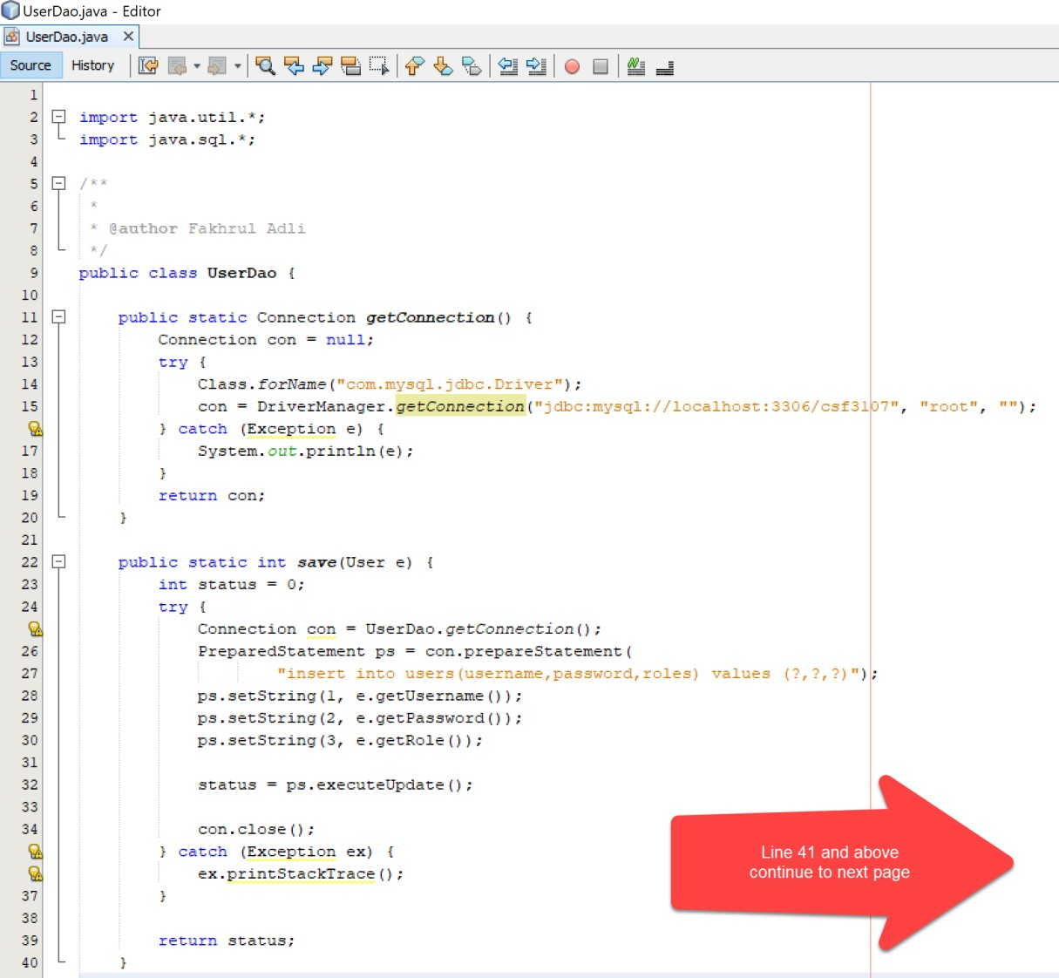Put the following codes in UserDao.java file. Make sure your database URL is correct, and database user credentials are also valid.
2. …continued.

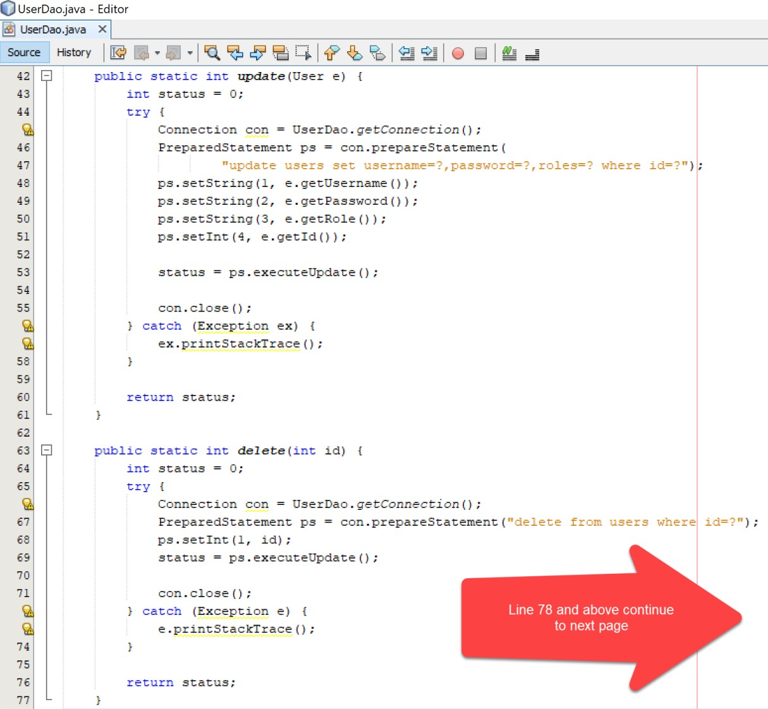

1. …continued.

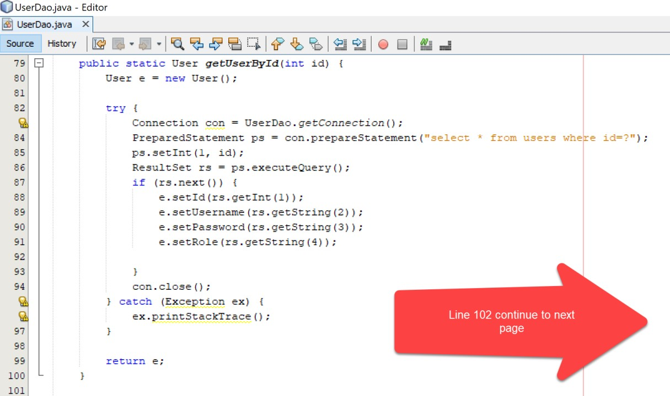

1. Save (CTRL+s) UserDao.java file.

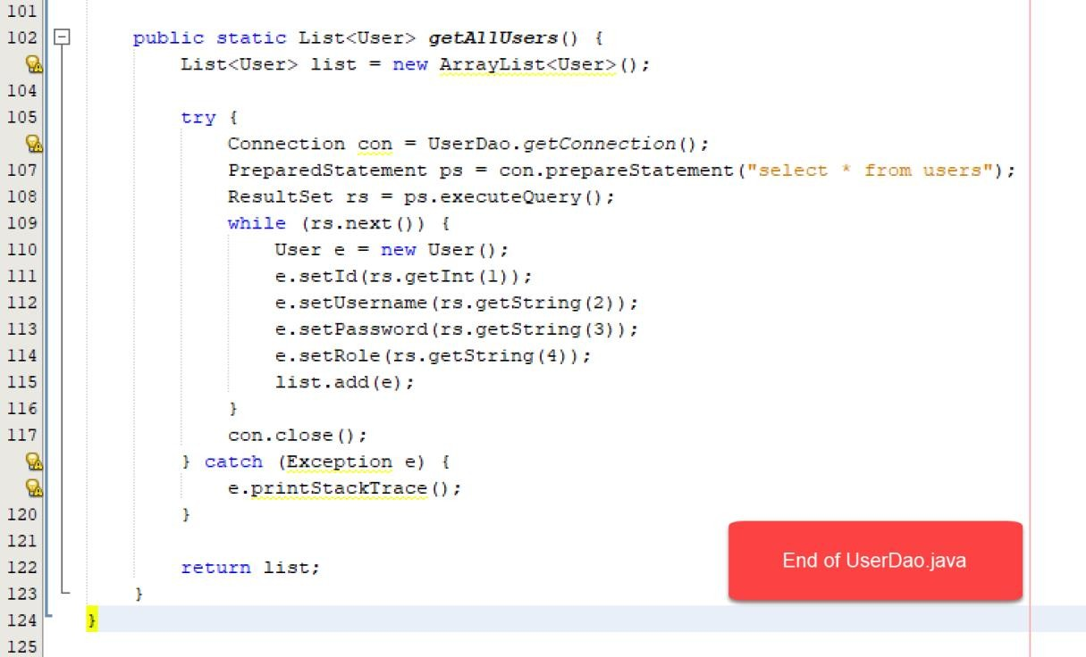

1. After finish coding the UserDao.java, now we are to code the servlet for saving data into the database.

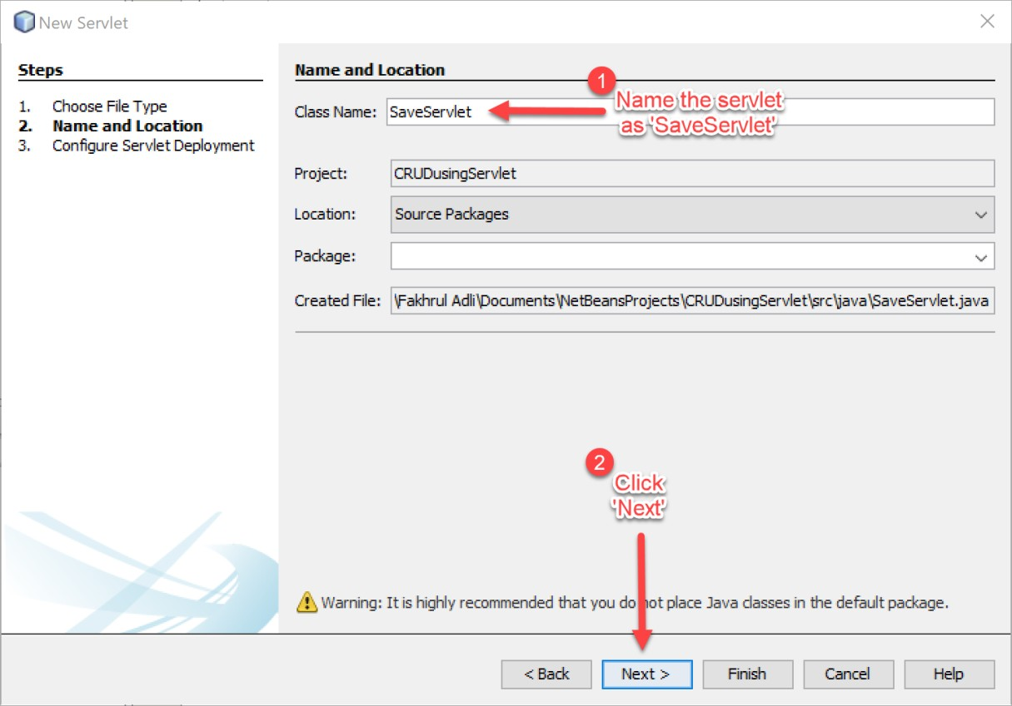

1. Remember to tick the checkbox every time you create a new servlet.

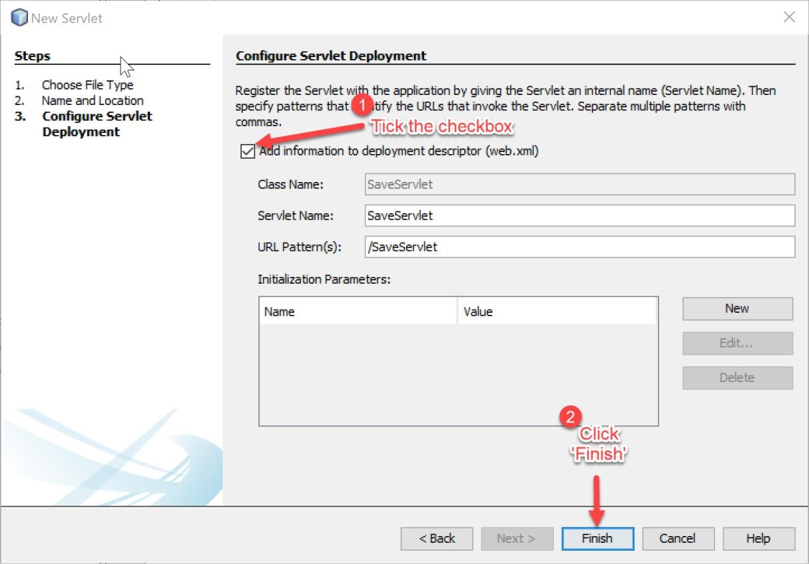

1. Make sure all related libraries are included in the SaveServlet.java file.

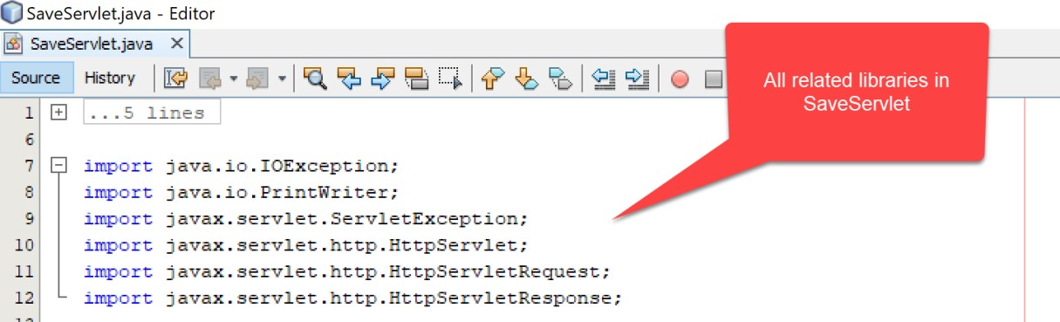

1. Type the following codes in processRequest() method.

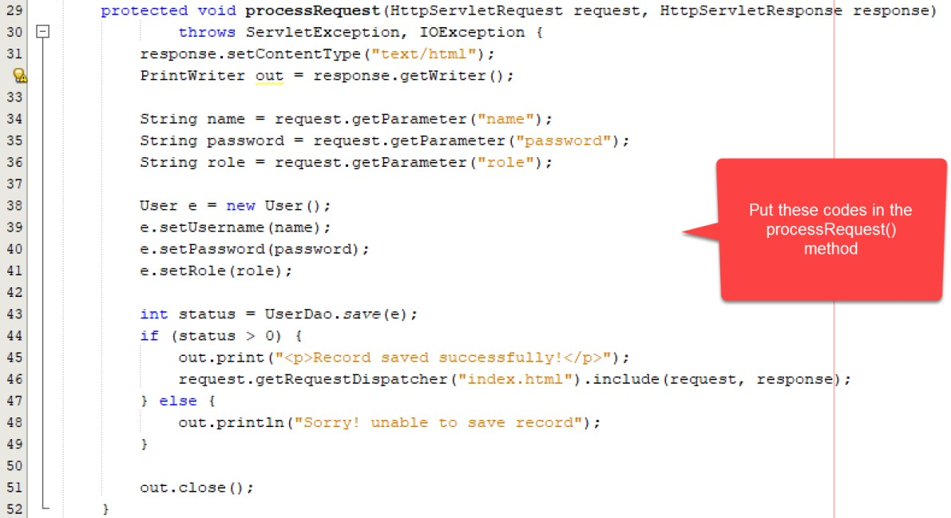

1. Save the file after finished.
2. 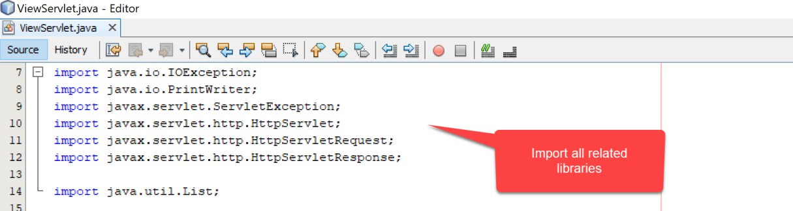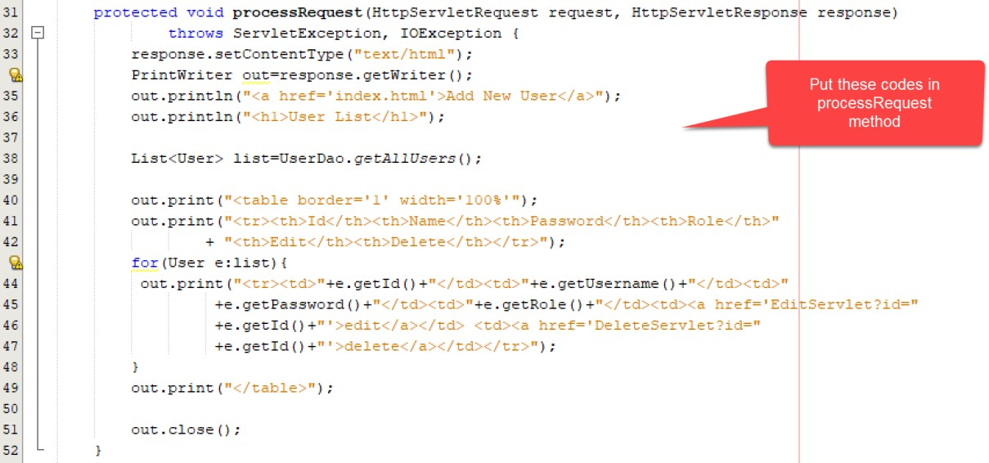Next, we are going to create a servlet to view our data in database. Create a new servlet *ViewServlet*, tick ‘Add information to deployment descriptor (web.xml)’ and click finish. Insert the following codes to the servlet.
3. Currently, we have finished creating a servlet for saving and viewing the data in the database. Now, we need a servlet to handle the process of editing the existing data stored in the table in the database.

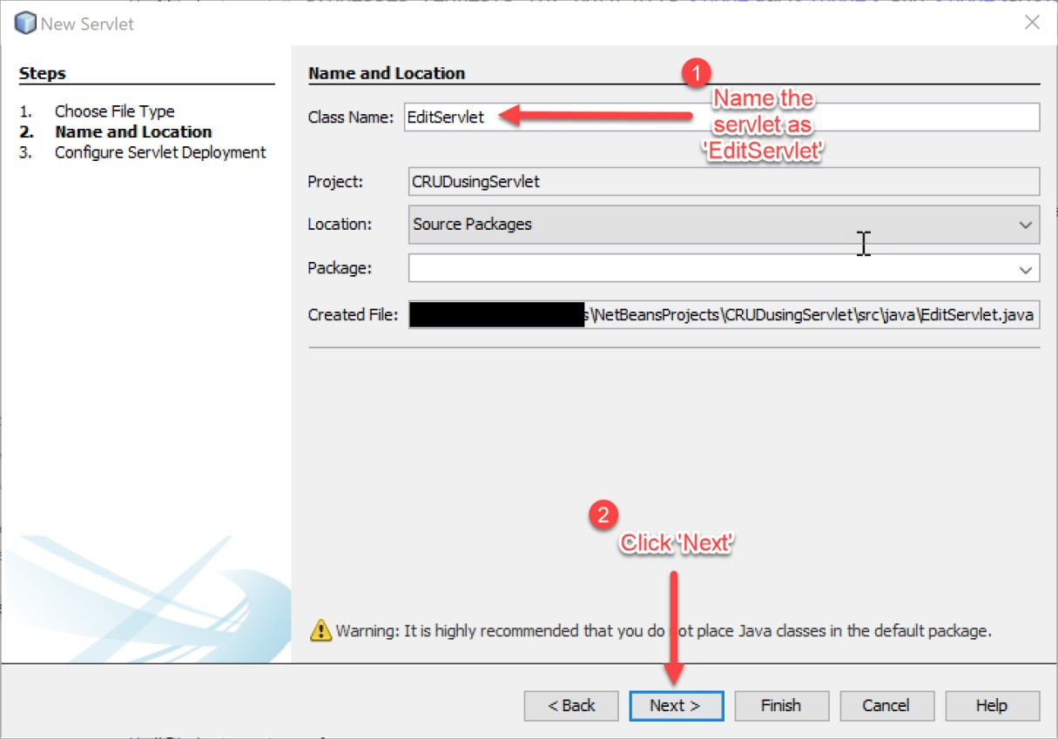

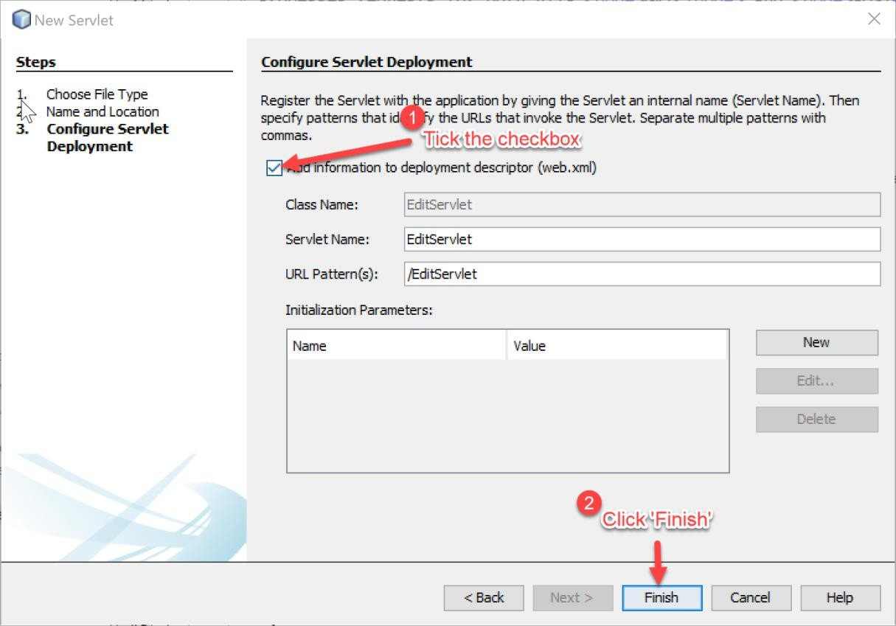

1. Type the following codes in the servlet you just created.

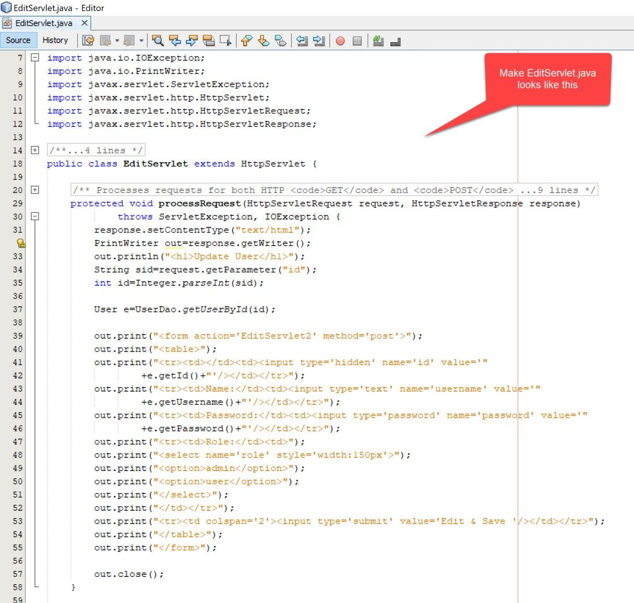

1. The previous servlet for editing data is for displaying the form as below:

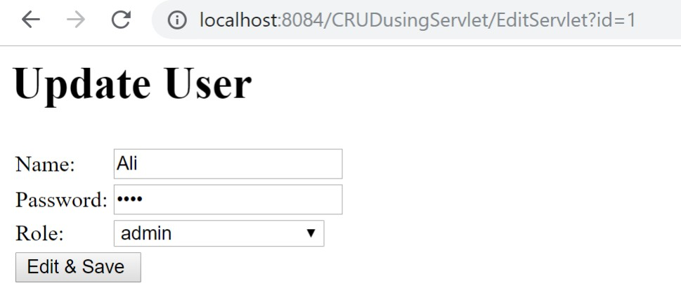

1. Now, we need another servlet to handle database processing.

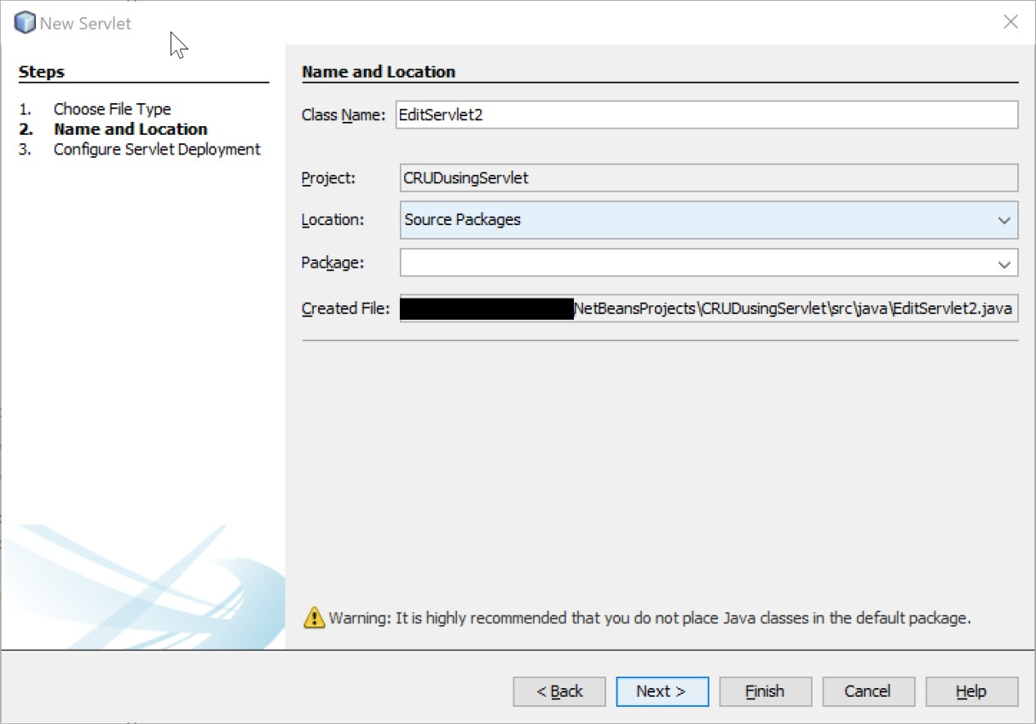

1. Remember to tick ‘Add information to deployment descriptor (web.xml)’. Netbeans will configure the servlet in web.xml on your behalf.

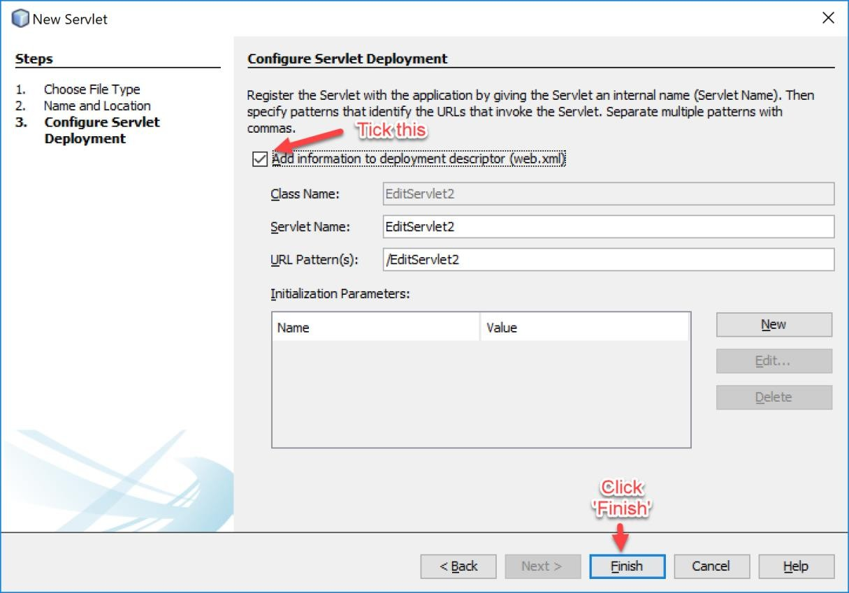

1. Type the following codes in the processRequest() method in EditServlet2.java. Save the file when you have finished.



1. Now we already have servlets for edit and saving the data, so the last servlet we need to provide is a servlet for deleting the data.

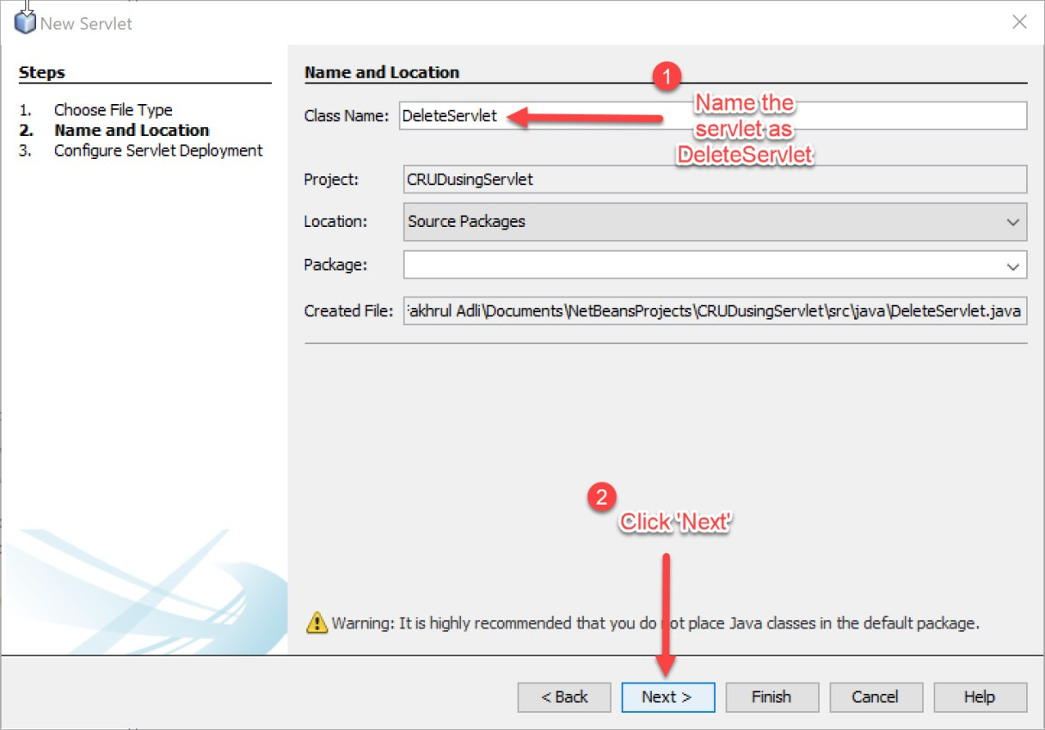

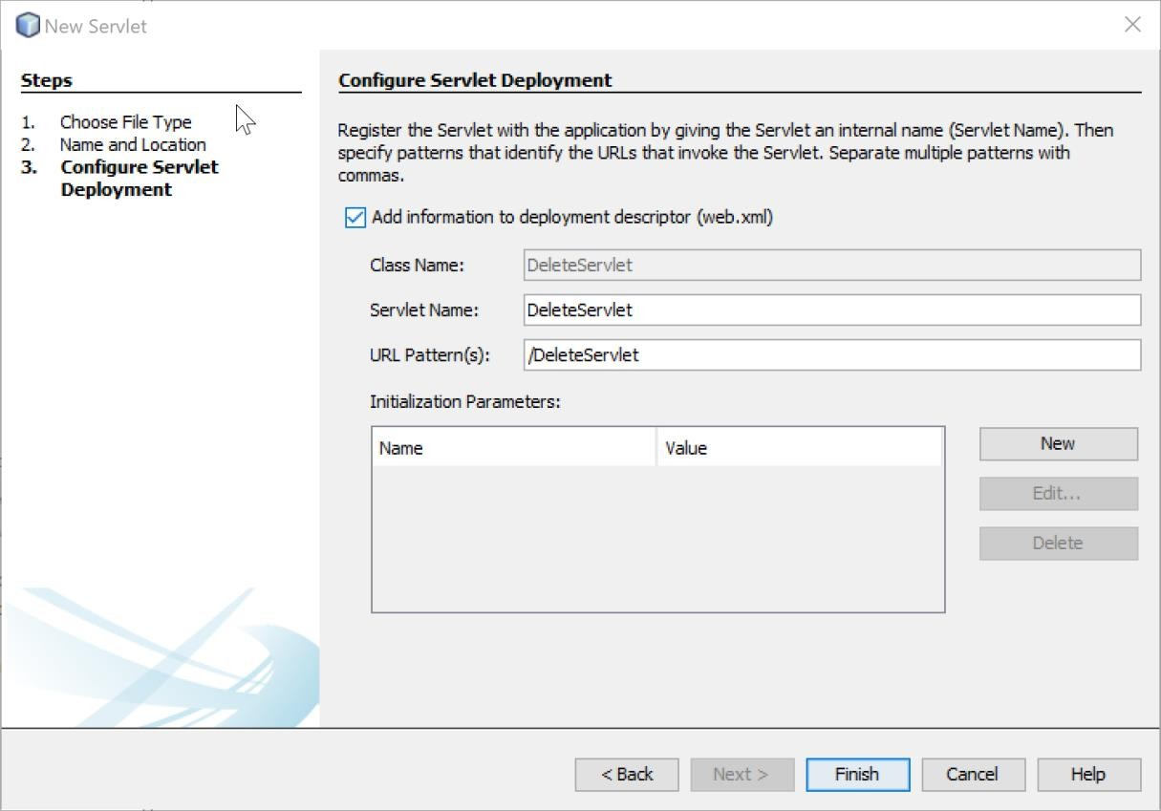

1. Write the codes below into your DeleteServlet.java file. Save the file when you have done.

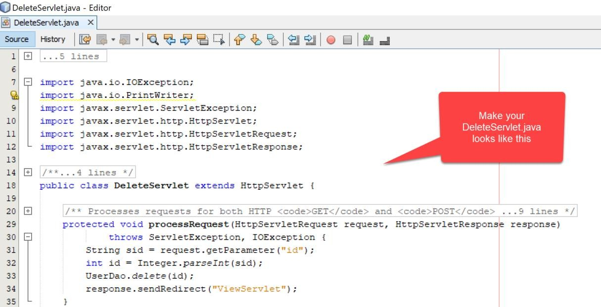

1. Run all the CRUD process of your servlet applications. In the end, you should be able to (C)reate, (R)etrieve, (U)pdate and (D)elete the data in the database.

# Reflections:

1. **What is the name of the Java Library that you need to import before coding the web application with database operations?**

JDBC (Java Database Connectivity) library.

1. **Which folder keeps the web.xml file? Copy the contents of the file and explain in brief the tags included such as <servlet-name><servlet-class>**

**<servlet-mapping>. etc.**

web.xml file which is typically located in the WEB-INF directory

1. **Define the usage of Data Access Object (DAO) servlet. How it ease the business process in your servlet-based web application?**

is a design pattern used in servlet-based web applications to separate the business logic from the data access logic.